**Mobile Programming homework#3(lab4)**

**201533661 이승수**

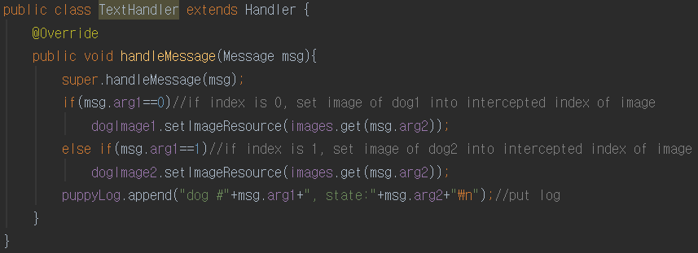

At TextHandler, get message from MyThreads and apply it on UI because MyThread can only access UI through the main thread. TextHandler set ImageView with random number in msg.arg2, which means index of ArrayList images. ImageViews are identified by msg.arg1.



getRandomTime() and getRandomIndex() return integer between min and max. They are used to randomly select thread’s sleeping time and image’s updated index. Time is between 1~4 second.

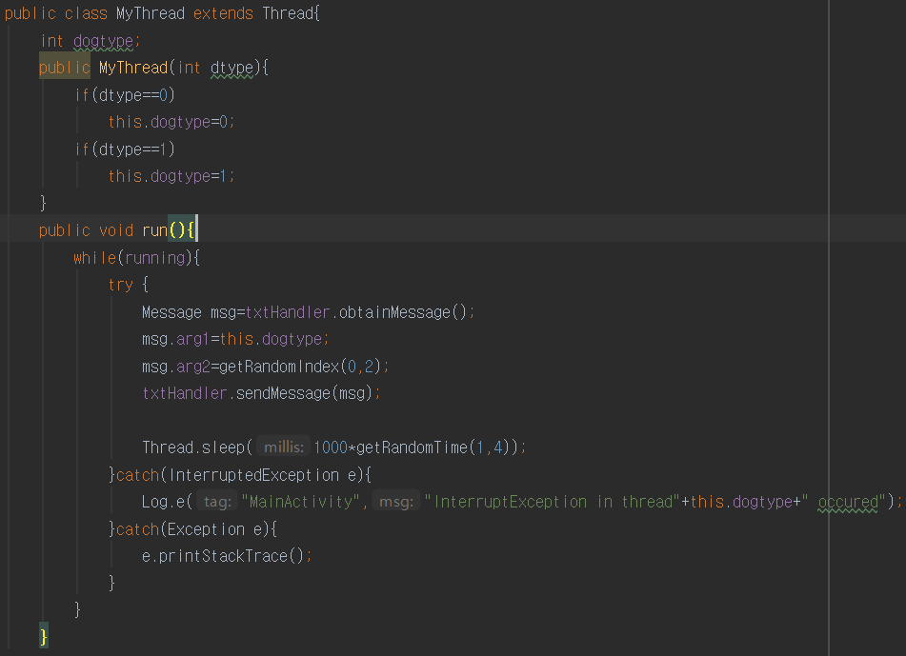

MyThread is thread extends Thread class. At constructor, it set dogtype attribute by parameter, which goes into msg.arg1. MyThread’s function is in run(). It gives dogtype value, image’s index to handler with msg and then make MyThread to be delayed for 1~4 seconds.